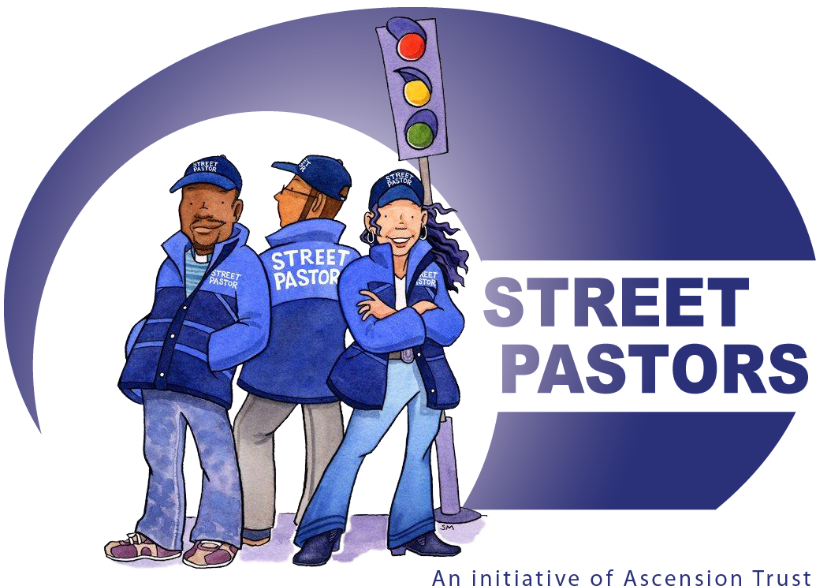

Sutton Community Works
Application Form - Street Pastor Course
PLEASE CLEARLY PRINT ALL DETAILS IN BLACK INK AND BLOCK CAPITALS

Please state the area to which you would like to do a Street Pastor Course

Please state the area to which you would like to be a Street Pastor

Personal Details

Surname
First Name
Address
Postcode
Email: |  |  |  | Work:
Mobile: |  |  |  | Home:
Date of Birth |  |  |  | Marital Status: |  | Single/Married/Divorced
Nationality |  |  |  | Profession
Do you have a driving licence? |  |  |  | Do you have use of Vehicle?
Coat Size  Please circle | S | M | L |  | XL |  | XXL | XXXL
Shirt Size Please circle. Collar size | 15inc | 15.5inc | 16inc |  | 16.5inc |  | 17inc | 17.5inc
If your collar size is larger than this please let us know.

CHURCH / ORGANISATION DETAILS

Church Organisation
Minister’s Name
Main Church Contact:
Address:
Postcode:
Telephone No: |  |  |  |  | Mobile No:
Email Address:

CHRISTIAN HISTORY

How Long have you been a Christian:
Give a brief account of your conversion:
Give a brief account of your spiritual growth and development since conversion:
Describe your relationship with your Pastor/Leader and your church
Are you involved in any form of Ministry in your church or in some other Christian Organisation? Eg: Children/Youth work/teaching/leading worship/admin/community work/hospitality/ if yes please state clearly what this involves.
Please state your reasons for wanting to be a Street Pastor
What are your expectations from the Street Pastors Course?
Are you able to fully finance this course? | Y | N
If no, how do you plan to raise the finance?

YOUR SKILLS

What are your hobbies/interests
Are you skilled in any performing Arts? Singing, dancing, acting, music, other
Do you have an up-to-date First Aid Certificate | Y | N
Do you possess any skills not mentioned above, which you feel would be useful as a Street Pastor?

YOUR HEALTH

Do you suffer from any medical condition we need to be aware of?
Are you currently on any medication? If so, please give details: Y/N
Are you subject to any dietary restrictions:

Emergency Contact information

Please give the name, address and telephone number of two emergency contact people.
Name 1 |  |  | Relationship
Address:
Postcode:
Home NO: |  | Mobile NO:
Name 2 |  | Relationship
Address
Postcode
Home NO: |  |  | Mobile NO

References

Two references are required, one from your Church Leader and the other from a Christian who has known you for at least three years.
Reference 1: Name:
Address:
Home No: |  |  | Mobile No:
Email:
Reference 2: Name:
Address:
Home No: |  |  | Mobile No:
Email:

Confidentiality
Any information relating to people using the service, acquired in the course of duty, must be treated in strictest confidence and must be discussed only within the confines of the work setting with the appropriate team leader/co-ordinator.

I agree to the relevant personal details being held on file and the computerised database. I confirm that I will notify Sutton Community Works of any changes. I understand that under the Data Protection Act, with prior notification, I have the right to access this information.
All information gathered as part of the core operation of Sutton Community Works is considered to be a ‘legitimate interest’ of our organization in providing this service. This is outlined in more detail within our Privacy Policy which can be viewed by clients, volunteers and other stakeholders at any time. Your personal data will only be used for the purposes of your role within Sutton Community Works.

Signed
Name

Please return this form to: Caroline Richards : admin.sutton@streetpastors.org.uk

